**RapidMass Software User Manual**

1. Functional introduction to the Identification Tab

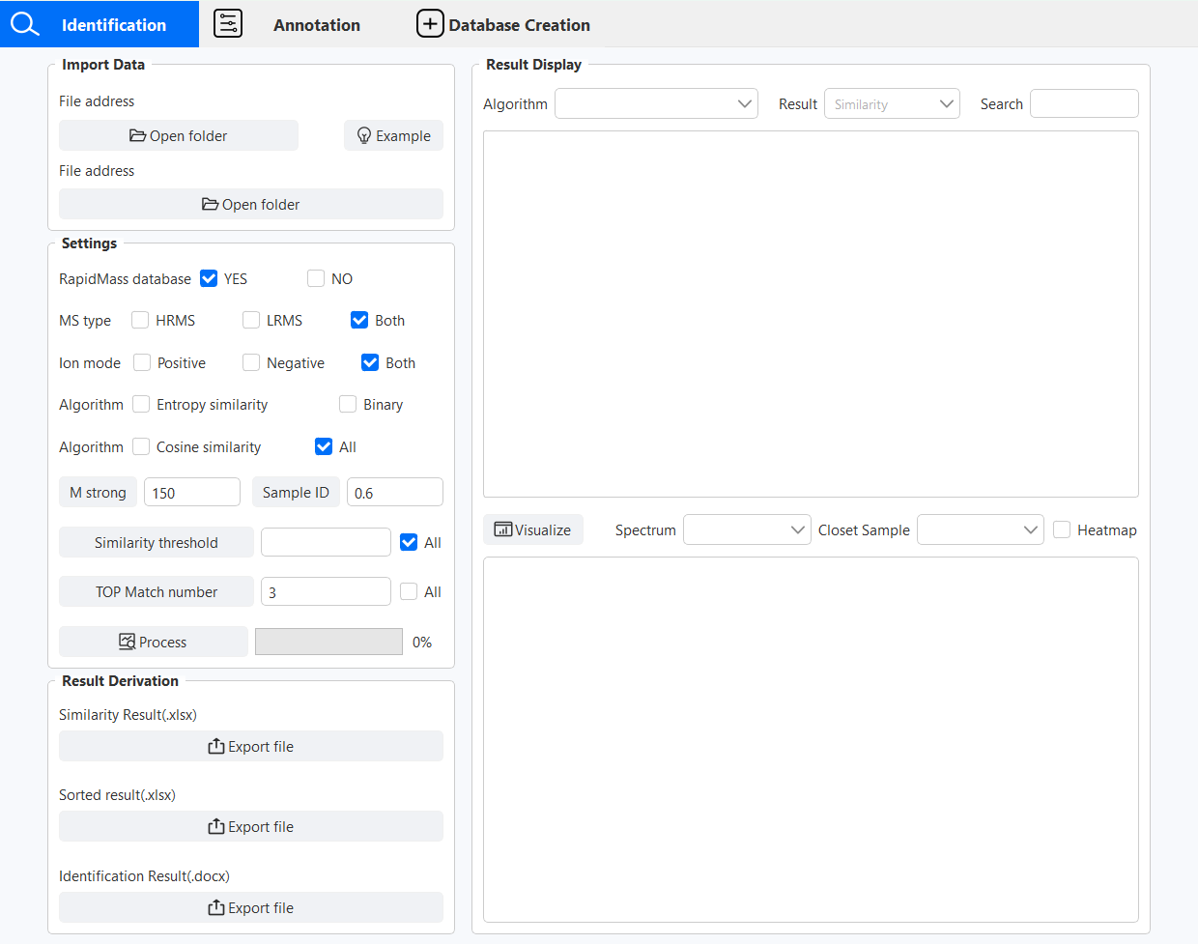

Figure 1 Identification Tab Interface

* 1. Importing data

Collect the mass spectrometry data of different rapid detection types, and save the mass spectrometry data extracted from the unknown samples in Excel file with m/z value and response intensity. Click “Example” to open the example file. Refer to the format of the example file, one sample is put in one sheet. Note that the Sheet is named Sample_Batch_InstrumentType_Ionmode. The form of the database file is also modelled on the format of the example file.

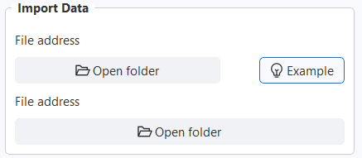

Figure 2 Open unknown sample and database file example file

Click on the first “Open folder” and select the file to import the unknown sample. The name of the file is displayed at the top of the screen after successful import. The second “Open folder” allows you to import a database file. The unknown samples are required, if no database file is imported, the RapidMass database will be used by default.

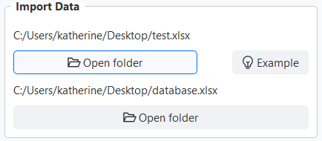

Figure 3 Example of importing unknown sample files and database files

1.2 Setting up the module

Set the parameters related to the database search, including whether the RapidMass database is used or not, whether the mass spectra of the collected data are of high-resolution type or low-resolution type, and the collection mode of the mass spectra. There are three database search algorithms, namely cosine similarity, spectral entropy similarity and binary code, which can be freely selected or selected all.

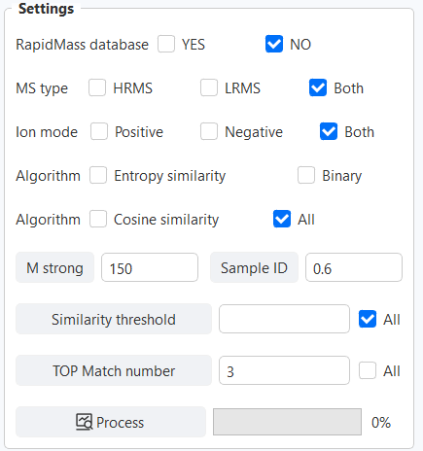

Figure 4 Parameter setting module

The binary code needs to construct the variety sequence named “Sample ID” for the database, traverse the database, extract the first M strong ions (M>0) of each sample, defined as 1, and the rest as 0. When the SampleName, InstrumentType and Ionmode of the samples are the same, then they are determined to be the same variety, and ions with a probability of existence within the variety greater than N (0>N>1) are considered to be the characteristic ions with a probability of presence greater than N within the variety are regarded as characteristic ions, and Sample ID of the variety is generated. then the data of the unknown sample is also extracted with the top M strong ions, and the similarity score is performed with Sample ID. the parameters recommended by DI-QDA and QI-QTOF are the top 150 strong ions and the probability of presence of 0.6. for other mass spectrometry types, the user can also optimise the parameters by RadpidMass software to get the best identification.After completing the parameter settings, click the “Process” button to start running, the right progress bar shows the progress in real time.



Figure 5 Display after completion of data processing

1.3 Export results

Similarity result, Sorted result and identification result can be exported via “Result Derivation” for further offline data analysis and processing. The results of the orthogonal table of similarity scoring results computed by the different database search algorithms selected are in excel file. The scoring results for each unknown sample are sorted and the sorted results obtained are in accordance with one column of matching samples and one column of matching scores statistics, also in the form of excel file. The final identification results are exported in the form of a word document.

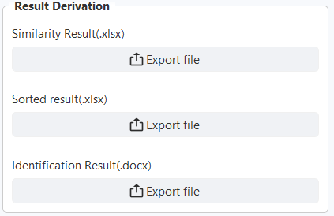

Figure 6 Result Export Module

1.4 Results Display

The results of the run are also displayed under “Result Display”. By switching between different algorithms and different types of results, you can directly see the identification results of unknown samples.

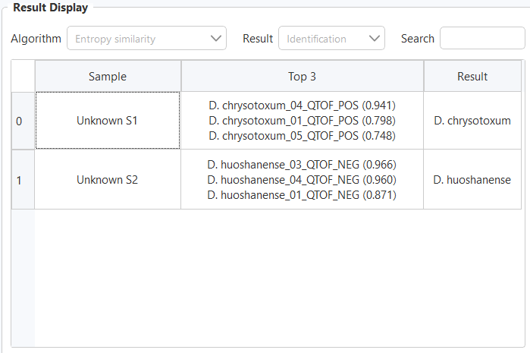

Figure 7 Tabular presentation of identification results under the spectral entropy similarity algorithm

When testing a large number of unknown samples or when you need to find any information quickly, you can enter something in the search box and press the Enter key to find it. The search will be displayed in bright colours.

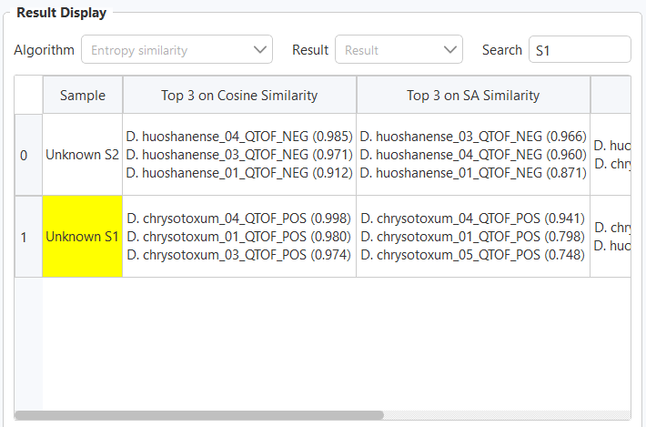

Figure 8 Find content display in table display

Click the “Visualize” button, the original spectrum of the unknown sample, the mirror image of the unknown sample and the most matched sample under different algorithms, and the comparison thermogram will be generated. The spectra can be zoomed in or out freely, and when the cursor is placed on the peaks in the spectra, the m/z value and abundance will be displayed automatically, and the images can be saved locally.

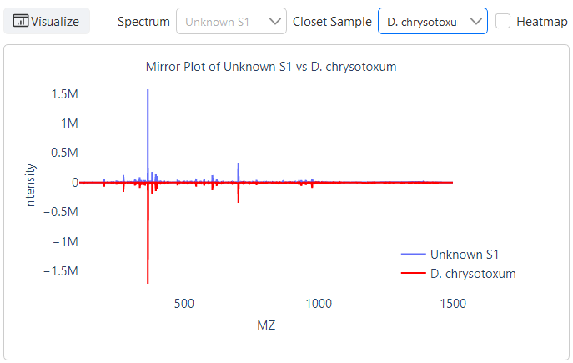

Figure 9 Mirror image of unknown sample with the best matching sample under different algorithms

1. Functional introduction to the Annotation Tab

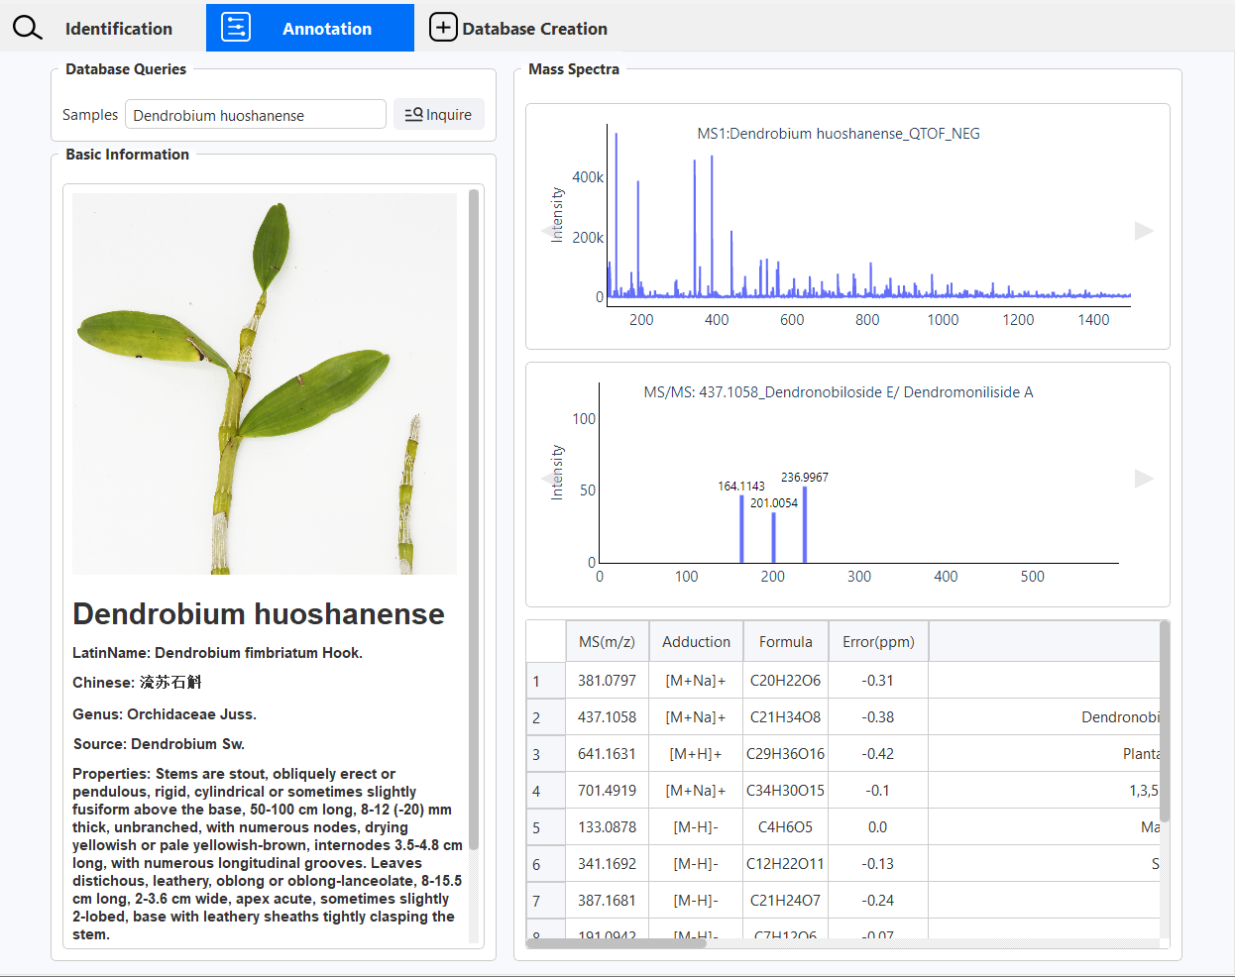

Figure 10 Annotation Tab Interface

Enter the Latin name in the search box and click the “Inquire” button to start searching. For example, if you search for “Dendrobium huoshanense” in this tab, you can view the information resources of this species in the “Basic Information” subsection, including the image data taken in our lab and the basic information such as English name, Chinese name, Latin name, genus, source, properties, distribution and so on.

The “Mass Spectrum” partition shows the MS and MS/MS spectra of the species collected by rapid detection mass spectrometry, which can be switched by clicking the triangle buttons on both sides. You can also zoom in and out freely, and when the cursor is placed on the peaks on the spectrum, its m/z value and abundance will be displayed automatically, and you can also save the image locally.

A list of peak information is displayed below the MS/MS spectrum and the table shows the results of the compound resolution for the characteristic ions of the species including m/z, chemical formula, adduction, fragment ions and so on.

1. Functional introduction to the Database Creation Tab

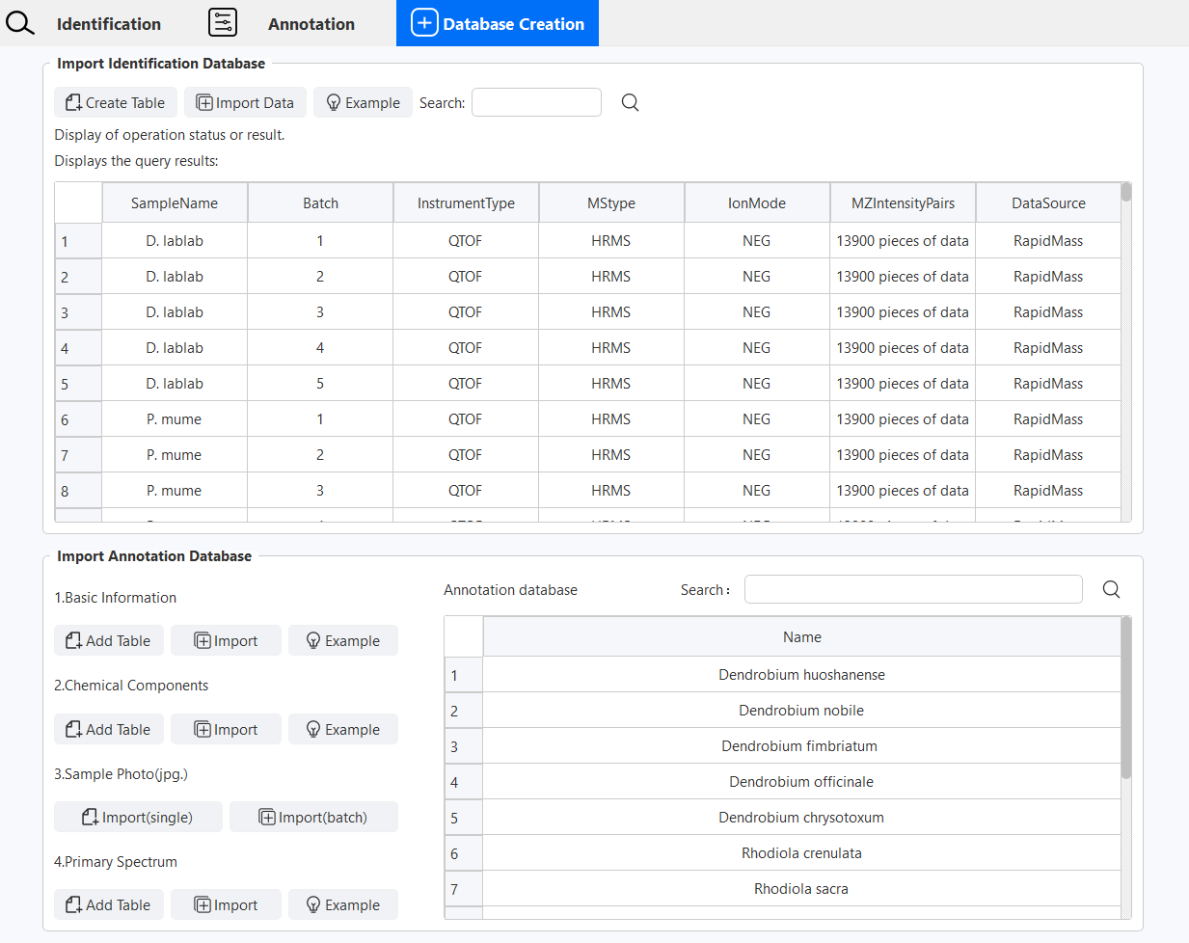

Figure11 Database Creation Tab interface

3.1 RapidMass Database

The RapidMass software has built-in identification databases of 2,380 mass spectrometry information from 595 batches of samples of 85 species using DI-QDA and DI-QTOF mass spectrometers in both positive and negative ion modes, including 540 batches of flowers from 78 species, 25 batches of *Dendrobium* from 5 species and 20 batches of *Rhodiola rosea* from 2 species. In addition, the RapidMass software has built-in annotation databases for 5 species of *Dendrobium nobile*, 2 species of *Rhodiola rosea* and 6 species of *Chrysanthemum morifolium*. Users can all view the data and use the databases for analysis through the RapidMass software.

3.2 Build, search and view Identification Database

Users can also create personal databases for data management and application, either by manual data entry or batch import of data files (csv., xls. or xlst.). Manual input requires SampleName, Batch, InstrumentType, MSType, Ionmode, and DataSource. SampleName is the Latin name or abbreviation of the sample. Batch indicates the batch of the sample. InstrumentType describes the specific type of instrument. MSType distinguishes whether the mass spectrum is high-resolution or low-resolution. And Ionmode labels the mode of acquisition, using either POS or NEG (not case-sensitive). The first column of the MZIntensityPairs is the m/z value, and the second column is the response intensity. DataSource refers to the specific source of the data.

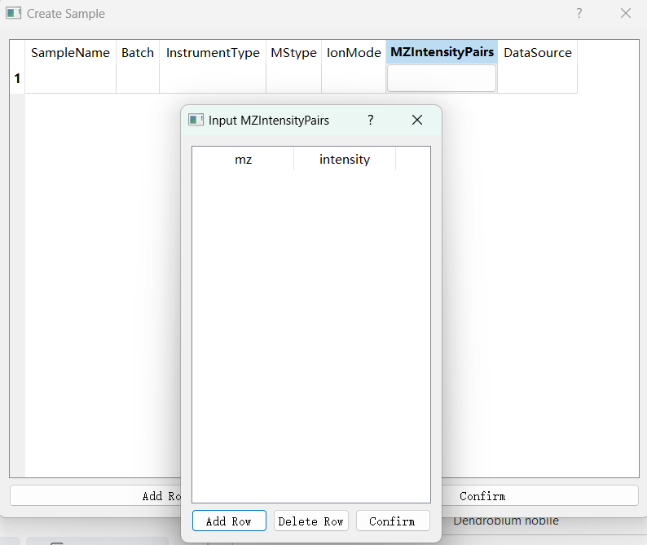

Figure 12 Separate import screen for identification database

The batch import uses an Excel sheet, the first sheet of the data file is the information for all the samples, and each subsequent sheet of data is the m/z values and response strengths for a different sample. You can refer to the example file for details. All sample information is stored in the RapidMass database after import. The import status and results are displayed in the “Display of operation status or result”.

The table shows all the contents of the database by default, you can fill in any information in the search box and click Query, the search results pop-up new search results form.

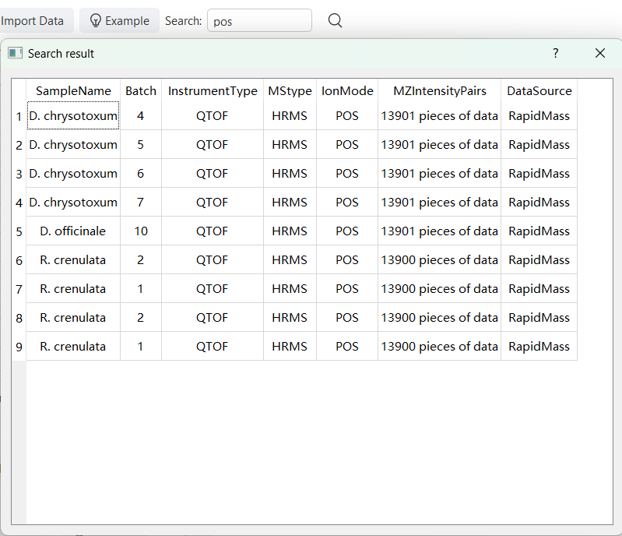

Figure 13 Example of search results by entering “pos” in the search box of the identification database

3.3 Build, search and view Annotation Database

The annotation database contains four parts: basic information, chemical components, sample photos and primary spectra. Reference example files can be imported individually or in batch, and the database list is viewed and searched in the table on the right. Enter text in the search box and click Query, the table will automatically update the search results.

Information: The system collates the basic information of each species, including Latin name, Chinese name, family and genus origin, properties, geographical distribution and its value, providing comprehensive background data for the database.

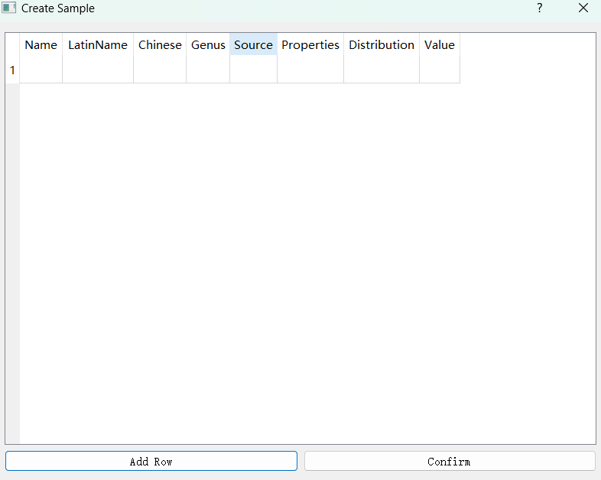

Figure 14 Separate import interface for basic information in the annotation database

Chemical composition information: Using the Fast DDA mode of the high-resolution mass spectrometer, the primary spectra of different species were collected in positive and negative ion modes, and the secondary spectra of the top ten ions were also recorded for detailed chemical analysis. For the feature ions with higher response in the primary spectra, the characteristic fragment ions in their secondary spectra were collected and combined with relevant literature and control products for chemical composition analysis. The analysis includes the exact mass number, adduction, molecular formula, error (ppm), identification, classification and its related fragment ion information.

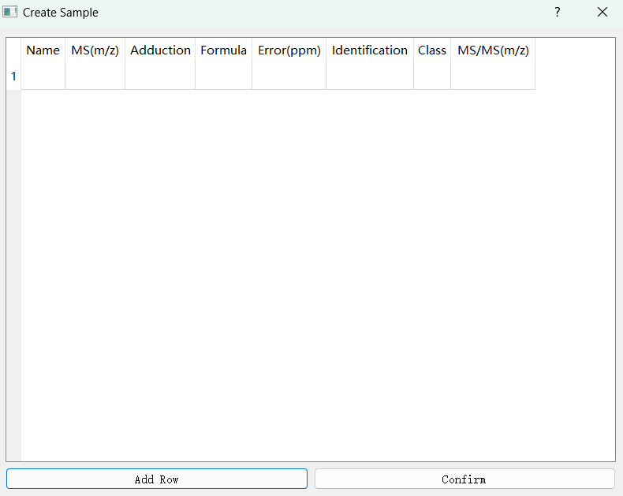

Figure 39 Interface for separate import of chemical components in the annotation database

Sample photographs: Representative plant morphological features of each sample were taken during the experiment for visualization in the database. Naming the photographed images as sample names allows them to be imported individually under the database for that species. If you put all the pictures in one folder, you can import them in bulk.

Primary spectrum: Primary spectra acquired by the mass spectrometer are extracted from the Total Ion Flow Chart (TIC) to extract MS spectral data within 1 minute, generating a list of MS1 data in terms of m/z value and Intensity, and each spectrum is placed in a sheet, the sheet is named Sample_Ionmode, which can be imported individually or batch-imported into the annotation database.

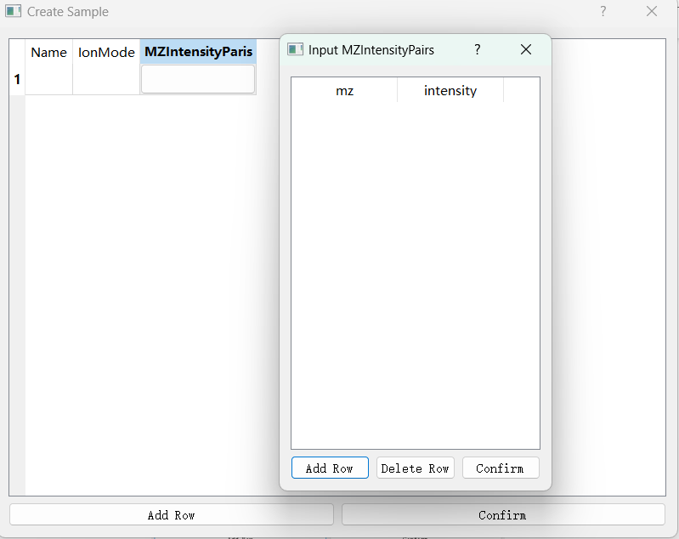

Figure 15 Separate import interface for primary spectrum in the annotation database